
Cape Cod Homeowner’s

Resource Guide

MEDIA KIT 2012

Cape Cod’s Trusted Buying Guide Since 2009

The BEST advertising value for your dollar!

www.capecodhrg.com

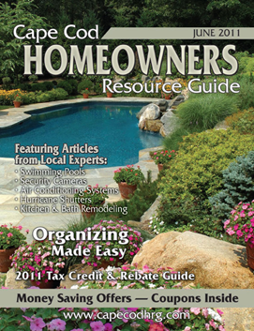
WHY ADVERTISE?

- Your ad will be read.

The Cape Cod Homeowners Resource Guide contains lots of valuable information, which means our issue is read cover to cover.

- Our readers save the guide and use it throughout the year.

Cape Cod HRG brings homeowners information that is valuable to them as they are making purchasing decisions. Many of our readers keep the guide for future reference which means your ads are seen over longer period of time.

- Cape Cod homeowners use our website search for qualified contractors, and trustworthy businesses.

The Cape Cod Homeowner’s Resource Guide is available on-line reinforcing your print media marketing dollars by giving you dual exposure through the Internet. Our website provides direct leads to our advertisers, and brings more people to your website. The content on our website is updated regularly providing relevant information to visitors and increasing our ranking within search engines.



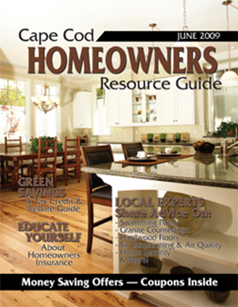

Demographics

The Cape Cod Homeowner’s Resource Guide is mailed in late May directly to 40,000 homeowners with assessed values over $300,000, targeting both primary and second-homeowners.

Magazine Copies……………………40,000
Pass Along Readership…………...100,000
Website Traffic……………………….10,000 unique visitors per year (estimated)
Annual Print & Online Audience.…150,000



Cape Cod Homeowners Resource Guide Spring/Summer 2012
- Direct Mailed in late May to 40,000 homeowners with assessed values over $300,000, targeting both primary and second-homeowners.
- All Ads include FREE online sales leads from the web
- Deadline 5/1/2012

Full Page Ad + Article + Coupon $ 2800.00
Inside Cover + Coupon $ 4200.00
Back Cover + Coupon $ 3200.00
Full Page Ad $1800.00
½ Page Ad $1200.00
¼ Page Ad $700.00
Coupon $200.00

For Advertising Information Call:
John Harrington ● (508) 776-0488
www.capecodhrg.com

